**BSEF17A511**

**Task 01:**

1.



2.





3.

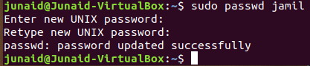

4.



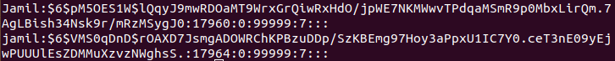

5.



6.

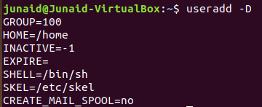

7.

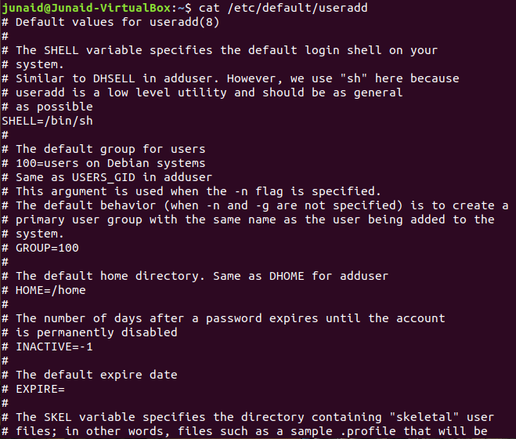

8.

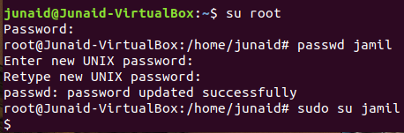

9.

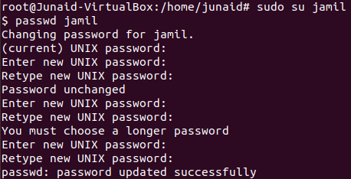

10.

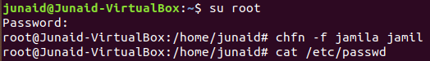



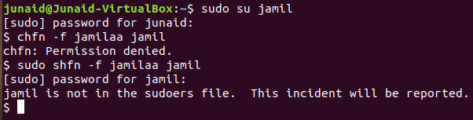

11.



**Task 02:**

1.

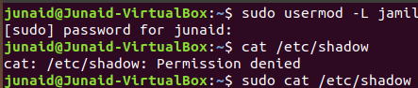





2.

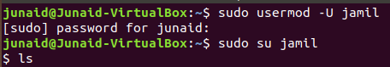



3.

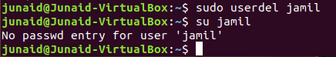

4.

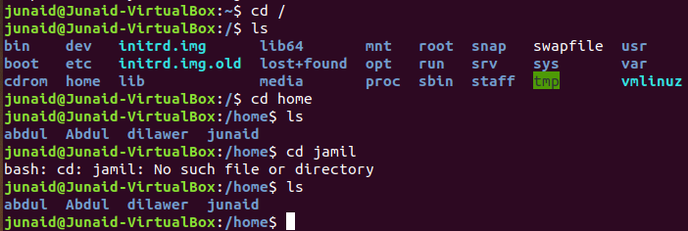

5.







6.

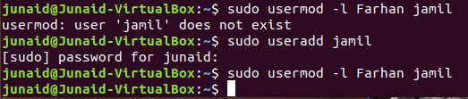

7.

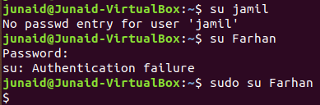

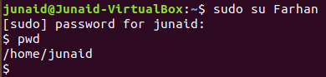

8.

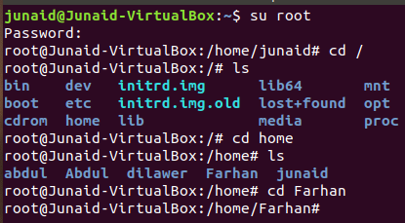

9.



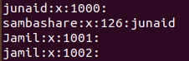



10.

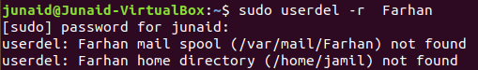



11.



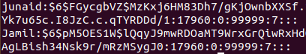



**Task 03:**

1.

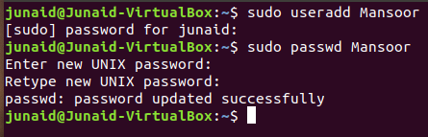

2.

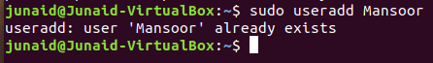

3.

OK

4.

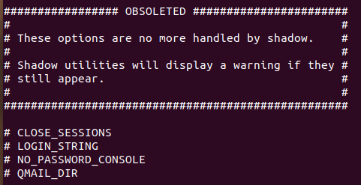



5.



6.



**Task 04:**

1.





2.





3.





4.







5.

Because primary group name is same as user name, so it cannot be deleted.



6.





7.





8.





9.



10.



11.



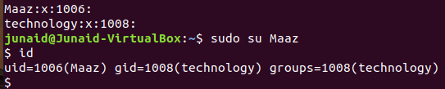

12.



13.

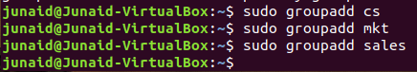

14.

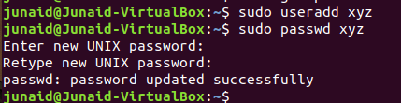

15.

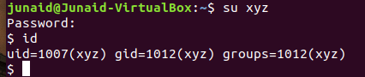

16.

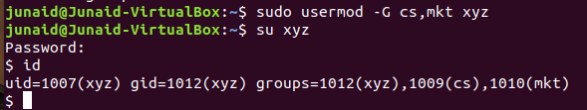

17.

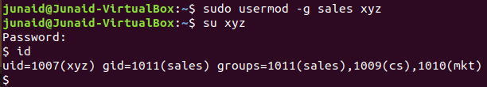

**Task 05:**

1.

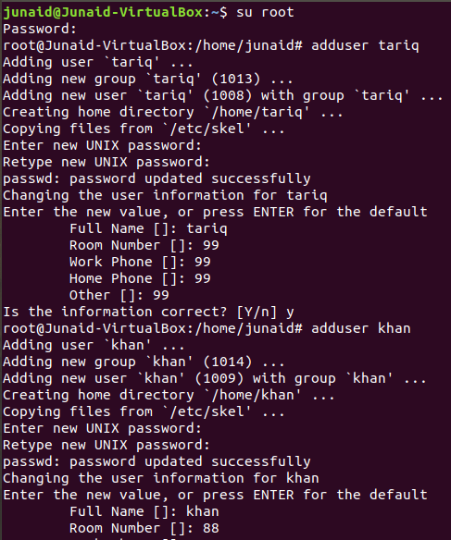

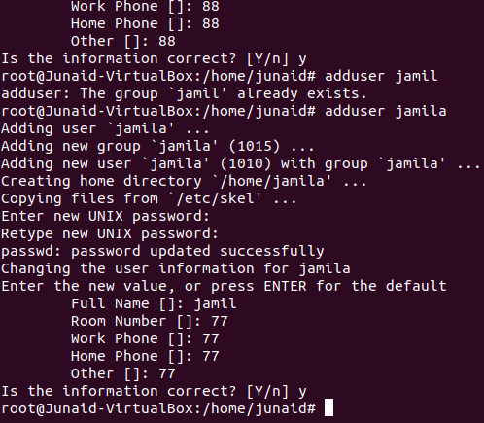

2.

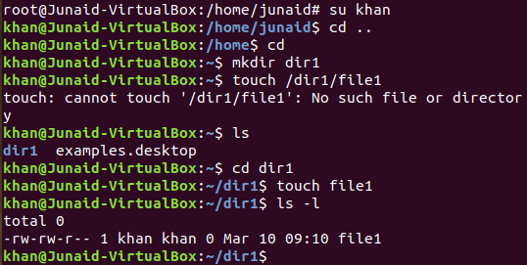

3.

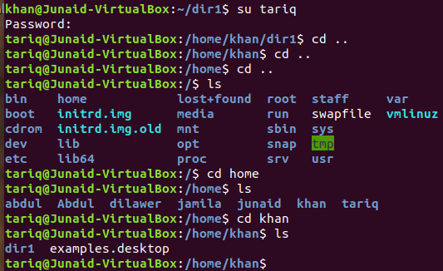

4.

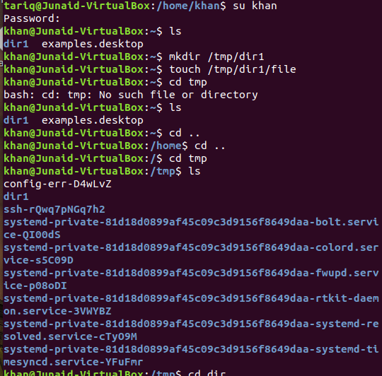

5.

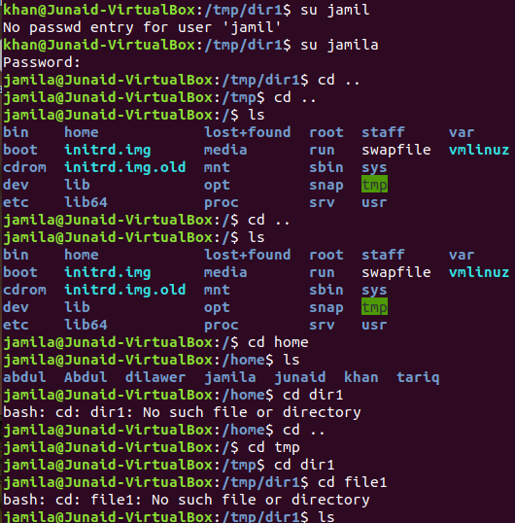

6.

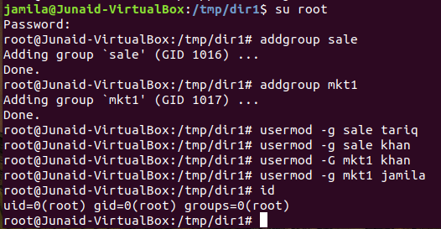

7.

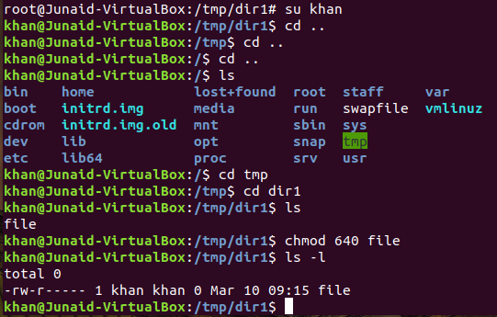

8,9.

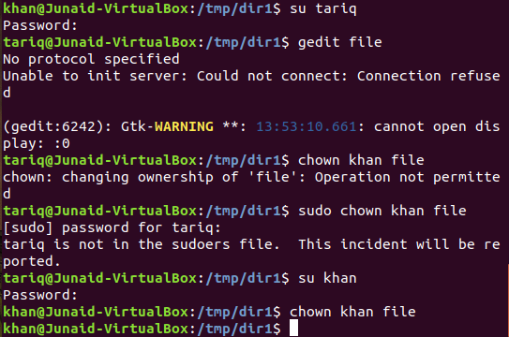

10.

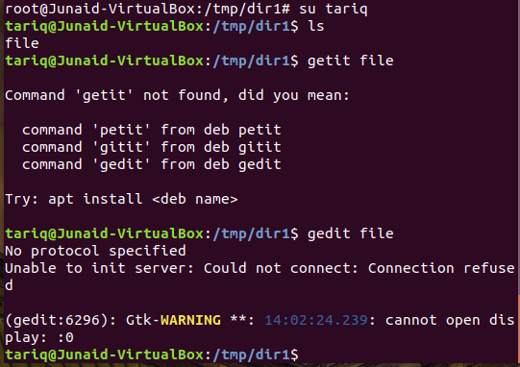

11.

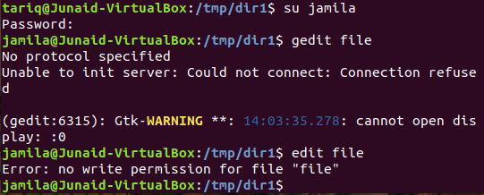

12.

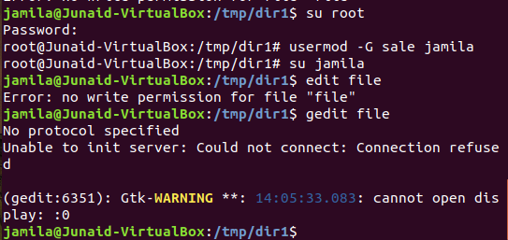

**Task 06:**

1.

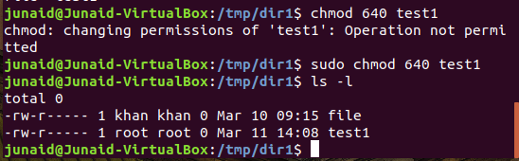

2.

**r=read,w=wtite,x=execution**

a. rwx-r------ permission to courses file.

b.user permissions rwx given to courses files.

c.rwx-------- permission given to ~ directory.

d.u=user g=group o=others all have rw permissions given to sample file.

e.eliminate all rw permission to sample file.

f.allow x permission to sample file.

g.group access gets equal to user access.

h.group access and other access becomes equal to user access (sample).

i.rwx-rwx-rw- permission to lab5 directory.

j.rwx-r-x---x permission to lab directory.

3.

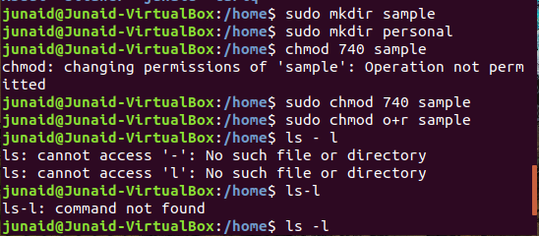

4.

The answer is no , other users are not able to read his file.

